Kindergarten Supply List
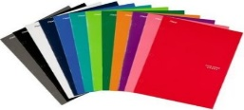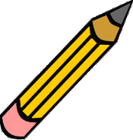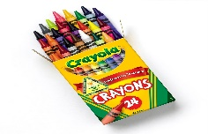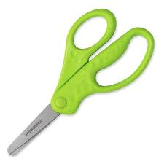

This Photo by Unknown Author is licensed under CC BY-SA-NC

- 5 K-2nd Grades Primary Composition Books __________________________________________________________

- - - - - - - - - - - - - - - - - - - - - - - - - - - - - - - - - - - - - - - - - - - - - - - - - - - - - -
__________________________________________________________
- 4 Plastic Two-Pocket Folders
- Headphones
- 2 Bottles of Glue
- 8 Large Glue Sticks
- 4 Boxes of Crayola Crayons (24 count)
- 1 Pencil Case
- 4 Packages of #2 Primary Fat Pencils (sharpened)
- 4 Packages of #2 Regular Sized Pencils (Sharpened)
- 1 Pair of Child’s Scissors
- 4 Packages of Dry Erase Markers
- 1 Package of Construction Paper
- 2 Packages of Copy Paper
- 3 Rolls of Paper Towels
- 3 Boxes of Tissues
- 2 Hand Soap
- 2 Hand Sanitizer
- 4 Boxes of Baby Wipes
- 1 Wash Cloth or Sock
- 1 Box of Quart Size Ziploc Storage Bags
- 1 Box of Gallon Size Ziploc Storage Bags
- A Change of Clothes. Please label all items with your child’s name in a Ziploc bag.

Please label your child’s name and class on All Supplies. Please have a set of supplies at home to complete all homework assignments and projects.

